Active Families Programme Evaluation

6-month Interim Report
July 2023
Active Families Evaluation Data
Programme Overview
Stride Active (Herefordshire) CIC has been funded by Active Herefordshire & Worcestershire and Herefordshire Council (Public Health) to continue the delivery of Active Families. Stride Active has commissioned Tiller Research Ltd to undertake an evaluation of the programme at the 6-month interval of this funding period and again at the end of the funding year.
Active Families has engaged 15 schools to date and has worked directly with 8 during this funding period. Schools have been identified based on IMD and NCMP data.

Evaluation Overview
Stride Active commissioned Tiller Research Ltd to undertake an evaluation of the outcomes of Active Families. This interim evaluation reviewed case notes and impact measures data collected by the project team between October 2021 and May 2023.

Profile of Active Families Participants
As of 2nd June 2023, Active Families had worked with:
- 291 clients
- 175 under 18s
- 99 adults
- 17 declined to provide their date of birth
- 65% female / 35% male
- 77% white British (16% did not state their ethnicity)
- Over half of clients (51.89%) live within the two most deprived areas within the county
Pathway:
- 216 had followed the MI Support pathway
- 75 had followed the Signposting pathway

Status:
- 241 clients had completed their involvement with Active Families
- 50 clients were still receiving support

Reasons for Engagement
Clients cited a range of different motivations for engaging with the Active Families programme. The reasons have been grouped according to key themes:
- Physical health, including weight loss, health conditions and “getting fitter”.
- Connectivity and activities as a family, between siblings or with other parents.
- To support mental wellbeing and other personal outcomes such as feeling calmer, reducing boredom or having a positive focus.
- Identifying activities with little or no cost, both within the home and in the wider community.
- To increase confidence to engage in physical activity, such as learning to swim or improving gross motor skills.

Qualitative Impacts of Active Families
Anonymised programme case notes were thematically analysed to identify the impacts experienced by participants. Five distinct themes were identified:
Theme One: Increased Physical Activity
- Clients have become more physically active following engagement with Active Families. This included increased walking for pleasure, walking instead of travelling by car or bus, swimming, playing sports, or using games and exercise equipment at home;
- Some families now engage regularly in walks together in local beauty spots, parks, or recreation grounds. Activity trails helped to entertain children in family walks;
- A few people had learnt or improved a specific physical skill, such as swimming, skipping with a rope, scooting, or ‘throwing-and-catching’, or had joined a club with coaching (e.g. martial arts, dance, swimming lessons);
- Active Families supported parents with children who were too young to join sports clubs. Parents were supported to find active games and activities or to use the free swim passes. Parents said that some activity bag items were particularly suitable for little hands or were tactile and brightly coloured and had quickly become a favourite toy;
- Some clients reported feeling more motivated to be active since taking part in the project.

Theme Two: Increased information and knowledge about accessible and local physical activities
- Practitioners provided participants with information about activities local to them which matched their interests and abilities;
- Cost was a barrier to activity for some families and had caused some parents to reduce or stop their children’s participation in fee-charging sports and activity clubs. Information about available discounts, free passes and low-cost or no-cost activities from Active Families was warmly welcomed;
- Practitioners gave participants with health-related barriers information about suitable and safe physical activities, building their confidence to participate;
- Parents were given information and resources to help them to engage their children in physical activities, including active games and walking;
- For signposting clients, the provision of information was often sufficient to engage them with one or more new activities;
- The support of practitioners empowered some clients to undertake further research about local activities by themselves and to explore the different options available to them.

Theme Three: Benefits of Play
- The activity bag and activity sheets provided by Active Families increased families’ motivation to play games. This also inspired creativity, with some inventing their own games using the equipment and/or buying additional equipment to add to their activity bag;
- Children, and sometimes adult family members, reduced the amount of time they spend recreationally online because they were spending more time playing games;
- Participants often spent increased time outdoors playing games, with siblings and families commonly playing together. The outdoor toys (e.g. frisbee, balls) encouraged participants to go outside, either using their gardens or taking the toys and games to local parks, friends’ or relatives’ gardens, or away on holiday;
- Many items in the activity bag were suitable for indoor play, as were lots of ideas on the activity sheets. These indoor play options were an important intervention as wet weather was a key barrier to being active, and some families lacked suitable outdoor spaces;
- Some families reported that their children now played independently offline more often, using their imagination and creativity. Some parents noted that the increased activity had reduced screen time, and others observed that having an activity bag close at hand had reduced children’s bad moods and episodes of boredom.
Theme Four: Positive Social Impacts
- Some parents reported that their children now played together more often and that conflicts between siblings had reduced;
- Children were engaging friends and other family members in outdoor games using items from the activity bag and making up games together;
- Social anxiety and difficulty in groups were a barrier to activity for some children and parents. Active Families were able to suggest activities that could be done at home alone or with familiar people, instead of having to attend a group or public facility.

Theme Five: Improved Health and Wellness
- Many participants commented that they had enjoyed the new physical activities. Some who had received signposting only reported having attended a class, using their free swimming passes or having engaged in other activities suggested to them;
- A few participants reported tangible improvements to their physical health and wellness, such as weight loss, increased energy, or improved sleep;
- Some participants had noticed improved mood in themselves and/or their children as their activity levels increased.

Impact Data
At the start of their involvement in Active Families, participants were asked:
- the number of days in the previous week they participated in sport;
- to complete the Short Active Lives survey (SALS), which estimated their total active minutes in the previous week;
- for adults only, to complete the WHO-5 Wellbeing Index;
- from January 2023, participants were also asked to complete the IPAQ activity questionnaire.
Where possible, these measures were repeated at the point of sign-off from Active Families. To date, 159 participants have completed the sport days measure at both the start and end of their involvement. In addition, 130 participants have completed SALS, 23 have completed IPAQ, and 21 adult participants have completed the WHO5 at both timepoints.
This section reports the changes experienced by those participants who completed the measures both at the start and end of their involvement with the project. For all measures, the distribution of data was examined in order to select an appropriate parametric or non-parametric statistical test.

Participation in Sports
At baseline, 47% of Active Families participants had taken part in sports during the previous seven days (M = 1.43 days, SD = 2.02). At sign-off, this had risen to 84% who had participated in sport on at least one day in the previous week (M = 3.21 days, SD = 2.41). This increase in participation in sports activities was found to be statistically significant and of a medium effect size (Z = -8.77, p <.001, r = -.49).

Adults (n = 41)
The number of days per week that adults participated in sport grew from a median average of 1 day per week at baseline to 4 days per week at sign-off. This was a statistically significant increase in physical activity and a medium effect size (Z = -4.34, p <.001, r =- 0.46)

Under 18s (n = 114)
The median average number of days participants aged under 18 years took part in sport at baseline was 0 days. This grew to a median average of 2 days per week at sign-off. This increase in physical activity was statistically significant and of large effect, (Z = -7.644, p<.001, r = -0.51).

Short Active Lives Survey
The Short Active Lives Survey (SALS) is Sport England’s recommended physical activity measurement tool. The SALS questionnaire identifies the number of minutes of weekly moderate or vigorous physical activity an individual undertakes. This is then assigned one of three classifications based on the UK Chief Medical Officer’s Physical Activity Guidelines, which are different for adults and 5-18s:
- Adults:
  - Active: 150+ minutes per week
  - Fairly Active: 30 – 149 minutes per week
  - Inactive: less than 30 minutes per week
- 5-18 year olds:
  - Active: 420+ minutes per week
  - Fairly Active: 210 – 419 minutes per week
  - Less Active: less than 210 minutes per week

Adults- Moderate and Vigorous Physical Activity
Levels of moderate and vigorous physical activity undertaken by adults increased from an average of 94 minutes per week to an average of 256 minutes per week (Table A). A Wilcoxon Signed-ranks Test indicated that this increase was a significant and large effect, Z = -4.852, p<.001, r = -0.54.
The most notable change was in the amount of walking undertaken, with 76% of adult participants walking more at sign-off than they did at baseline. There was also a significant increase in the amount of time spent undertaking formal sport and fitness sessions (e.g. playing team sports, attending exercise classes), with 37% of adult participants engaging in these types of activity at sign-off compared with 5% at baseline.

Table A: Minutes per week of moderate or vigorous physical activity (Adults, n=41)
Element | Mean mins  (SD) Pre | Mean mins  (SD) Post | Test statistic  (significance) | Effect Size
Total | 94 mins  (SD 138.6) | 256 mins  (SD 225.2) | Z = -4.852, (p<.001) | r = -0.54  (large)
Walking | 71 mins  (SD 132.45) | 187 mins  (SD 168.4) | Z = -4.602, (p<.001) | r = -0.51  (large)
Cycling | 18 mins  (SD 43.6) | 36 mins  (SD 112.6) | Not significant | N/A
Sport / Fitness Session | 5 mins  (SD 23.1) | 33 mins  (SD 50.8) | Z = -3.301, (p<.001) | r = -0.36  (medium)

Adults- Classification of Physical Activity Level
At baseline, 51% of adult participants were classified as ‘inactive’; this had fallen to 10% by sign-off (see figure 1). The proportion of adult participants classified as ‘active’ more than doubled, from 24% at baseline to 56% at sign-off. The marginal homogeneity test showed that the difference in adult activity levels at the two time points was statistically significant
(MH statistic = -3.94, p<.001).
Figure 1: Classification of adult participant physical activity levels (n=41)
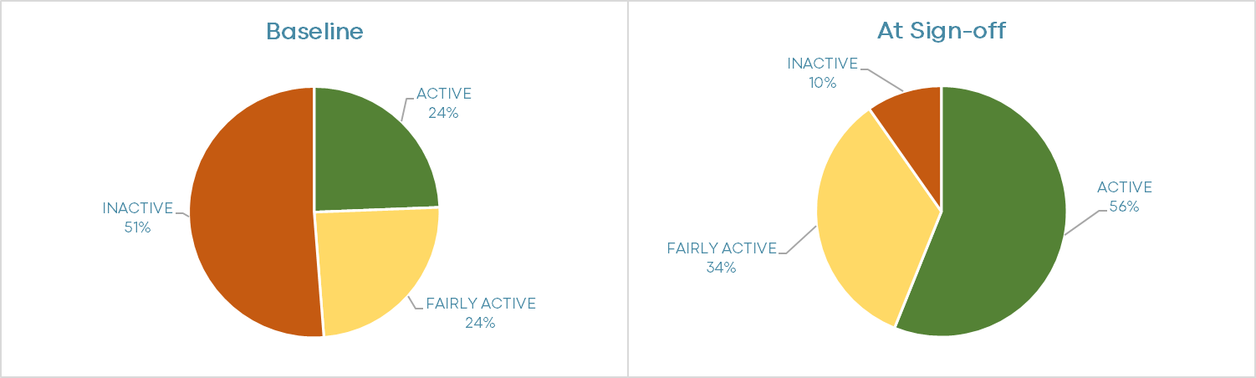

Under 18s- Moderate and Vigorous Physical Activity
Levels of moderate and vigorous physical activity undertaken by Under 18s increased from an average of 117 minutes per week to an average of 274 minutes per week (Table B). A Wilcoxon Signed-ranks Test indicated that this increase was a significant and large effect, Z = -7.847, p<.001, r = -0.59.
The proportion of under 18s undertaking moderate or vigorous walking increased from 45% at baseline to 84% at sign-off. For cycling, the proportion rose from 45% at baseline to 66% at sign-off. Those taking part in formal/organised sport and fitness sessions rose from 29% at baseline to 48% at sign-off.
Table B: Minutes per week of moderate or vigorous physical activity (Under 18s, n=89)
Element | Mean mins  (SD) Pre | Mean mins  (SD) Post | Test statistic  (significance) | Effect Size
Total | 117 mins  (SD 147.0) | 274 mins  (SD 196.4) | Z = -7.847, (p<.001) | r = -0.59  (large)
Walking | 45 mins  (SD 78.2) | 136 mins  (SD 109.0) | Z = -7.122, (p<.001) | r = -0.53  (large)
Cycling | 54 mins  (SD 94.6) | 94 mins  (SD 121.6) | Z = -5.407, (p<.001) | r = -0.41  (medium)
Sport / Fitness Session | 19mins  (SD 31.7) | 44 mins  (SD 60.7) | Z = -4.718, (p<.001) | r = -0.35  (medium)

Under 18s- Classification of Physical Activity Level
Just 3% of under-18s were classified as ‘active’ at baseline, meeting the recommended level of an average 60 minutes per day of moderate or vigorous physical activity. This had risen to a quarter (25%) at sign-off (figure 2). An additional 34% of under-18s were undertaking an average of between 30 and 60 minutes of physical activity a day at sign-off.
The proportion of under-18s classified as ‘less active’, and so undertaking less than an average of 30 minutes physical activity a day, fell from 82% at baseline to 42% at sign-off. The marginal homogeneity test showed that this difference in activity levels at the two time points was statistically significant (MH statistic = -6.53, p<.001).

Figure 2: Classification of under-18 participant physical activity levels (n=89)
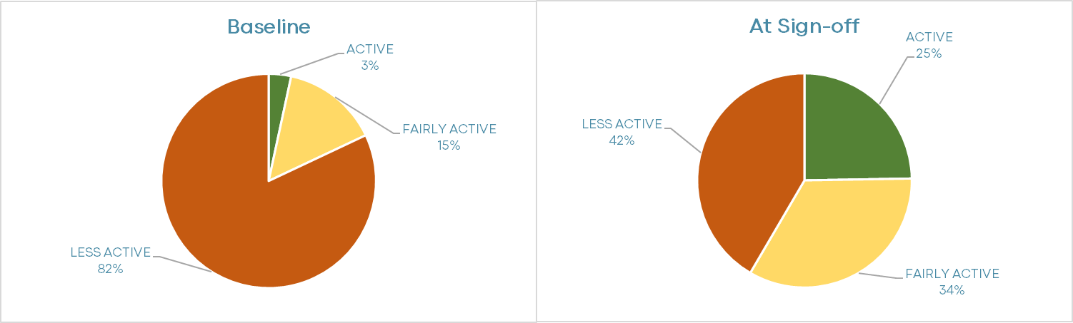

International Physical Activity Questionnaire (IPAQ)
The International Physical Activity Questionnaire (IPAQ) is an alternative measure of physical activity, which calculates the metabolic equivalent time of physical activity (MET minutes). Active Families participants have completed this measure since January 2023. By the end May 2023, 23 participants had completed the IPAQ at baseline and sign-off.
Median physical activity levels increased from 338 MET minutes per week at baseline to 951 MET minutes per week at sign-off. A Wilcoxon Signed-ranks Test indicated that this increase was a significant and large effect, Z = -4.198, p<.001, r = -0.619.

WHO-5 Wellbeing Index
The WHO-5 measure includes five items, each of which are self-assessed on a 0-5 scale. The total is multiplied by four to create an overall percentage. A WHO5 score below 52% indicates poor psychological wellbeing.
Of the 21 adult participants in Active Families who completed the WHO-5 measure at both timepoints, fewer than half (48%) scored above the wellbeing threshold at baseline. Following participation in Active Families, wellbeing improved, with 81% of participants scoring above the wellbeing threshold at sign-off. The results of the related t-test show that this difference is statistically significant, with a very strong effect size, (t(20) = -5.58, p<.001, d = -1.22).
Table C outlines the responses to each of the five items. The most notable change was to the statement ‘I have felt cheerful and in good spirits’. All the other items saw a modest improvement, except for ‘my daily life has been filled with things that interest me’ for which no significant change was observed.

Table C: WHO-5 scores at baseline and sign-off from Active Families (n=21)
Item | Median Response Baseline | Mean Response Sign-Off | Test statistic  (significance) | Effect Size
I have felt cheerful and in good spirits | 1 (some of the time) | 4 (most of the time) | Z = -3.44, (p<.001) | r = -0.53  (large)
I have felt calm and relaxed | 3 (more than half the time) | 4 (most of the time) | Z = -2.83, (p=.005) | r = -0.44  (medium)
I have felt active and vigorous | 3 (more than half the time) | 4 (most of the time) | Z = -2.803, (p=.005) | r = -0.43  (medium)
I woke up feeling fresh and rested | 2 (less than half the time) | 3 (more than half the time) | Z = -2.78, (p=.005) | r = -0.43  (medium)
My daily life has been filled with things that interest me | 2 (less than half the time) | 2 (less than half the time) | Not significant | N / A
WHO-5 total score (%) | 48% | 68% | t(20) = -5.58, (p<.001) | d = -1.22  (v strong)

Evaluation Results Summary
This interim analysis has shown that Active Families is making a positive difference to the adults and young people participating in the project. Levels of physical activity have increased significantly, with a particularly large increase in informal activity such as walking and active games.
Increased information and knowledge about accessible and local physical activities has led to increased activity levels, with particular successes observed through ‘rethinking’ what being physically active means. The benefits of play and family time have been observed alongside improved wellbeing and positive social impacts.
The data will be revisited at the end of the project in order to undertake a full project evaluation.

Case Studies
Family 1: Reducing anxiety, increasing creativity
Mum feels anxious when she takes the children out too far. Active Families bag provided for the family.
3 weeks: AF bag always out for children to play with. Daughter loves to play with it and the boys do when home from school. Daughter aged 2 has using bean bags and likes throwing them. Boys like the chalk. They are active 3-4 times a week for 30-60 minutes.
12 weeks: Mum asked for HALO pass. AF bag being used 2 x 45 minutes. The family are adapting and creating new games, such as adding different size boxes to the ‘socks in a box’ game and making it harder to score points: shoe box 5 points, cat food box 10 points and egg box 15 points. Another game they use fruit shoot bottles used as skittles.
Mum says they are getting out of the house and kids enjoy it!
When asked if she thought they were more active as a family mum said “massively more active now and we have now got a puppy! Mindset has changed now because kids are more active, they are more upbeat and happier. It's something to focus on rather than sitting and watching TV. Kids aren't on tablets as busy doing activities.”

Family 2: Active together
Large family, wanting to reduce time in front of technology. A range of activity ideas were provided, alongside an AF bag.
Week 4: They play the corn hole game, made out of a cardboard box with holes cut into it and throw bean bags through them. Use catch ball daily and skipping rope. Play with the bag on and off throughout the day throughout school holidays.
Week 6: Still playing with the AF bag and corn hole game. Bean bags used every day. Velcro catch lost its sticky surface as it has been used that much! Bag used every day for 60 minutes.
Week 12: They are all very active, much more than before and spend a lot less time on tech. Playing football 5 x 2hours a week. Only a couple of the children would have done that before but now all of them play. Still love the AF bag, especially the skipping rope; they have bought more catch ball pads and use the bean bags for balance and throwing games. They use the bag 2-3 days a week and for around 60 minutes each time.
When asked what difference Active Families has made: “The children play better together and now all so the same sort of thing they are not arguing as used to when playing games. It is improving mental health too.”

M = mean average
SD = standard deviation
Z = Wilcoxon Signed-Ranks Test result
p = significance value. p<0.01 means that there is a greater than 99% probability that the observed result is not due to chance, p<0.001 means that there is a greater than 99.9% probability that the observed result is not due to chance
r = effect size. r = 0.1 is considered a low effect size, r = 0.3 is considered a medium effect size, r = 0.5 is considered to be a large effect size.
Cohen’s d = effect size. < 0.5 is weak, 0.5<0.8 moderate, 0.8<1.2 strong, 1.2<2 very strong, ≥2 extremely strong.

