Children’s Safeguarding and Welfare Policy and Procedures

Covering good practice guidelines, accidents, incidents and reporting processes

Designated Safeguarding Lead: Emma Gardner

Deputy Designated Safeguarding Lead: Beky Williams

Policy publication date: 6th July 2021

Date of last review: 2nd December 2022

Date of next review: 1st December 2023

Contents

Page | Section | Contents
3 | 1 | Policy Statement
4 | 2 | Policy Aims
4-5 | 3 | Identifying types of abuse
5-6 | 4 | Safer Recruitment
 | 4.1 | Code of Conduct
6-9 | 5 | Responding to and reporting allegations, suspicions or concerns
 | 5.1 | Emergency Procedure
 | 5.2 | Disclosure from a young person
 | 5.3 | Missing young person
 | 5.4 | Injured young person
 | 5.5 | Fatality of a young person
 | 5.6 | Recording an incident
 | 5.7 | Information sharing
 | 5.8 | Allegations
 | 5.9 | Confidentiality / Whistleblowing
9-10 | 6 | Use of photographic/filming equipment
 | 6.1 | Schools and parents/carers
 | 6.2 | Stride Active
10-11 | 7 | Social Media and online safety
 | 7.1 | Managing our online presence
 | 7.2 | Responding to online communication
11 | 8 | Duty of Care
12 | Appendix 1 | Incident Report Form
13 |  | Post incident follow up
14 |  | Post event procedures
15 | Appendix 2 | Flow Chart for Responding to an incident
16 | Appendix 3 | Missing Young Person Procedure
17 | Appendix 4 | Seven golden rules of information sharing
18 | Appendix 5 | Contacts
19 | Appendix 6 | Risk Grid
20 | Appendix 7 | Policy amendments
21 | Appendix 8 | Stride Active Employee Code of Conduct
22 | Appendix 9 | Checklist for external providers

- Policy Statement

Stride Active (Herefordshire) CIC (hereafter referred to as Stride Active) supports schools in Herefordshire and beyond to raise the profile of PE, sport and physical activity, whilst also working with local community organisations and families to raise the profile of physical activity. This is through professional development, tailored support, events and activities.

Stride Active acknowledges the duty of care to safeguard and promote the welfare of children and is committed to ensuring safeguarding practice reflects statutory responsibilities, government guidance and complies with best practice. Furthermore, this policy aligns with those organisations for whom Stride Active are working on behalf of, such as host schools (Whitecross Hereford and Kington Primary School).

This policy is mandatory for all employees delivering Stride Active events, activities and services.

This policy applies to the work of Stride Active employees.

Within this policy, the term ‘employee’ will refer to any paid employee of Stride Active, or anyone working on a formalised paid or unpaid basis, including volunteers.

A young person is defined as a person under the age of 18 (The Children Act 1989). The policy recognises that the welfare and interests of young people are paramount in all circumstances. It aims to ensure that regardless of age, ability or disability, race, religion or belief, sex or sexual orientation, socio-economic background, all young people:

- have a positive and enjoyable experience through Stride Active events, activities and services where they can participate in a safe and child centred environment
- are protected from abuse whilst participating in Stride Active events, activities and services.

Stride Active acknowledges that some children have an increased risk of abuse, and additional barriers can exist for some children with respect to recognising or disclosing it. We are committed to anti-discriminatory practice and recognise children’s diverse circumstances. We ensure that all children have the same protection, regardless of any barriers they may face.

Where events, activities and services are provided by Stride Active, our own Safeguarding Policy and Procedures will apply in conjunction with the host venue, host school or participating school / organisation where appropriate. If other organisations provide services or activities on behalf of Stride Active, we will check that they have appropriate procedures in place, including safer recruitment procedures.

The primary responsibility for the supervision of young people participating in Stride Active events, activities and services remains with the accompanying school staff representative, or parents/carers when outside of a school environment. Schools must ensure they supervise young people at all times and adhere to staff to child ratios, in line with their own risk assessments. For any Stride Active events where it has not been made compulsory for external staff to attend or where we have been contracted to deliver a service, Stride Active will assume responsibility for those young people.

The policy will be reviewed annually by Stride Active or whenever there is a significant change in legislation (see appendix 7 for amendments).

- Policy Aims

As part of our safeguarding policy Stride Active will:

- promote and prioritise the safety and wellbeing of young people
- assign a Designated Safeguarding Lead (DSL) and Deputy Safeguarding Lead for the organisation
- ensure everyone understands their roles and responsibilities in respect of safeguarding and are suitably prepared to respond to any incidents or emergencies, whilst ensuring that they are protecting themselves
- ensure appropriate action is taken in the event of incidents/concerns of abuse and support provided to the individual/s who raise or disclose the concern
- ensure that confidential, detailed and accurate records of all safeguarding concerns are maintained and securely stored, in line with data protection guidelines
- ensure safer recruitment is practised amongst employees and volunteers
- ensure robust safeguarding arrangements and procedures are in operation.

- Identifying types of abuse

There are four main forms of abuse and the effects of each can be highly damaging, both emotionally and physically, to a young person. We recognise that:

- both male and females can be the abusers and can be adults and other young people
- the abuser is usually well known and trusted by the young person
- that abuse can happen anywhere - at work, at home, at school and in the community
- any kind of abuse can happen to a young person

Physical Abuse
Physical abuse may involve hitting, shaking, throwing, poisoning, burning or scalding, drowning, suffocating, or otherwise causing physical harm to a young person. Physical abuse also includes giving a young person poison, alcohol or inappropriate drugs. Physical harm may also be caused when a parent or carer feigns the symptoms of, or deliberately causes ill health to a young person whom they are looking after. In some cases, the injuries will be caused deliberately. In others they may be accidental but caused by the young person being knowingly put at risk.

Neglect
Neglect is the persistent failure to meet a young person’s basic physical, psychological or emotional needs which is likely to result in the serious impairment of the young person’s health or development. It may involve a parent or carer failing to provide adequate food, shelter and clothing, failing to protect a young person from physical harm or danger, or the failure to ensure access to appropriate medical care or treatment. It may also include the neglect of, or unresponsiveness to, a young person’s basic emotional needs and failure to provide appropriate supervision to keep a young person out of danger.

Psychological Abuse
Emotional/psychological abuse is persistent or severe emotional ill-treatment of a young person that is likely to cause serious harm to his/her development. It may include threats of harm or abandonment, deprivation of contact and affection, humiliation, rejection, blaming, controlling, intimidation, coercion, difference, harassment, verbal abuse including shouting or swearing, isolation or withdrawal from services or support networks. However, it can also include being so over-protective towards the young person that he/she is unable to develop or lead a normal life, exploiting or corrupting a young person or conveying the message that he/she is worthless, unlovable, inadequate or his/her only value is to meet the needs of another person. This may, or may not include racist, homophobic or other forms of abuse. Psychological abuse is the denial of a person’s human and civil rights including choice and opinion, privacy and dignity and being able to follow one’s own spiritual and cultural beliefs or sexual orientation.

Sexual Abuse
Sexual abuse occurs when someone uses power or control to involve a young person in sexual activity in order to gratify the abuser’s own sexual, emotional or financial needs or desires. It may include forcing or enticing a young person to take part in sexual activities, whether or not they are aware of what is happening. The activities may involve physical contact, including penetrative or non-penetrative acts. They may include non-contact activities, such as involving a young person in looking at, or in the production of, pornographic material or watching sexual activities, or encouraging them to behave in sexually inappropriate ways

Child-on-child abuse
Child-on-child abuse is when children abuse other children. This type of abuse can take place inside and outside of school and online. Peer-on-peer abuse is most likely to include, but may not be limited to:
- Bullying (including cyber-bullying, prejudice-based and discriminatory bullying)
- Abuse in intimate personal relationships between peers
- Physical abuse such as hitting, kicking, shaking, biting, hair pulling, or otherwise causing physical harm (this may include an online element which facilitates, threatens and/or encourages physical abuse)
- Sexual violence, such as rape, assault by penetration and sexual assault (this may include an online element which facilitates, threatens and/or encourages sexual violence)
- Sexual harassment, such as sexual comments, remarks, jokes and online sexual harassment, which may be standalone or part of a broader pattern of abuse
- Causing someone to engage in sexual activity without consent, such as forcing someone to strip, touch themselves sexually, or to engage in sexual activity with a third party
- Consensual and non-consensual sharing of nudes and semi nudes images and/or videos (also known as sexting or youth produced sexual imagery)
- Upskirting, which typically involves taking a picture under a person’s clothing without their permission, with the intention of viewing their genitals or buttocks to obtain sexual gratification, or cause the victim humiliation, distress or alarm
- Initiation/hazing type violence and rituals (this could include activities involving harassment, abuse or humiliation used as a way of initiating a person into a group and may also include an online element)

Where children abuse their peers online, this can take the form of, for example, abusive, harassing, and misogynistic messages; the non-consensual sharing of indecent images, especially around chat groups; and the sharing of abusive images and pornography, to those who don't want to receive such content.

- Safer recruitment

Stride Active and our host schools are committed to practising safer recruitment for both employed staff and volunteers. It is important that the individual has the right skills, knowledge and attitude for the role.

Our safer recruitment ensures we can screen out and discourage those who are not suitable for working with our organisation.

Safer recruitment means that prospective employees will:
- complete of an application form
- provide two referees
- be interviewed
- provide evidence of identity and qualification
- undertake a DBS check as appropriate to their role and be registered with the Independent Safeguarding Authority

Any appointed employee will receive an induction, in partnership with the host school and will be required to familiarise themselves with Stride Active’s and the host school’s safeguarding policy, alongside undertaking any additional training.

The following procedures will be adhered to when recruiting volunteers:
- volunteers will be given clearly defined roles and responsibilities and will be supervised by an adult with the appropriate and relevant approvals (safe recruitment processes and references)
- steps will be taken to confirm the volunteer’s qualifications are suitable for the role, if appropriate
- where possible, references will be sought for volunteers
- all new volunteers will complete an induction process which will include familiarisation with Stride Active safeguarding policy and procedures

When commissioning projects and work, Stride Active will compete a minimum operating standards checklist to ensure that safe recruitment has taken place (see appendix 9).

At some Stride Active events and activities, young leaders will be used to support delivery. Young leaders will therefore be provided with a safeguarding briefing where it will be made clear that they should report any action that they feel is inappropriate to an adult. Stride Active believes that the adults working on behalf of Stride Active have the prime responsibility with regard to safeguarding and that the role of the Young Leader is to communicate concerns to them.

4.1 Code of conduct
All employees must adhere the Stride Active Code of Conduct (see appendix 5). Any breach of the Code of Conduct may be dealt with under the employer’s Disciplinary Procedure.

- Responding to and reporting allegations, suspicions or concerns

It is not the responsibility of Stride Active employees to decide whether or not abuse has taken place. However, there is a responsibility to act on any concerns by reporting these to the appropriate officer or the appropriate authorities. This procedure applies to any Stride Active employee who has concerns about the safety and protection of a young person. Stride Active employees must assess the situation and take action using the flowchart in appendix 2.

5.1 Emergency procedure
If the young person is in need of emergency medical attention or immediate danger (including missing young person – see 5.2), Stride Active employees must follow this emergency procedure:

- remain with the young person and call the police
- if the young person is elsewhere, contact the police and explain your concerns
- if the young person requires emergency medical care, call an ambulance and if available, seek assistance from a First Aider
- Contact the DSL or Deputy DSL as soon as you are able to

5.2 Disclosure from a Young Person
A disclosure is when a young person tells you something that has affected them, for example about instances of abuse. A young person may make a disclosure to a Stride Active employee directly or indirectly through an activity. Behaviour and non-verbal communication could also be other ways a young person may make a disclosure. It is not the responsibility of Stride Active employees to decide whether or not abuse has taken place. However, there is a responsibility to act on any concerns by reporting these to the DSL or the appropriate authorities. This procedure applies to any Stride Active employee who has concerns about the safety and protection of a child. Stride Active employees must assess the situation and take action using the flowchart in appendix 2. If a young person makes a disclosure to a Stride Active employee, an incident report form must be completed and shared with the DSL in line with 5.6. In addition, you should:
- remain calm, approachable and receptive
- listen carefully, without interrupting
- acknowledge you understand how difficult this may be
- make it clear that you are taking what is said seriously
- reassure them that they have done the right thing in telling you
- not promise confidentiality

5.3 Missing Young Person
In the event of a young person going missing at a Stride Active event or activity, the lead Stride Active employee will be responsible for following missing young person procedures. Following an organised search, and multiple announcements, if after 20 minutes the young person has not been located, the police will be contacted. See appendix 3 for procedure.

  - Injured Young Person
Where a school is responsible for young people at a Stride Active event/activity, in the event of an injury, the school staff representative will take primary care. Stride Active will be responsible for completing an incident report form (appendix 2) and storing this in line with data protection regulations.

Where a Stride Active employee is the responsible adult, through a contracted service, they will be responsible in the event of an injury for the primary care of that young person (including the identification of a trained first aider). Stride Active will be responsible for completing an incident report form and storing this in line with data protection regulations.

  - Fatality of a young person
In the event of the death of a young person at a Stride Active event or activity, the Stride Active DSL will notify the Child Death Review Co-ordinator in the relevant local authority as soon as is possible once the emergency services are in attendance.

5.6 Recording an incident
This procedure (see flow chart in appendix 2) applies to any Stride Active employee who may be concerned about the safety and protection of a child. This procedure must be followed whenever an allegation is made that a child has been abused, or when there is a suspicion that a child has been abused. Promises of confidentiality should not be given as this may conflict with the need to ensure the safety and welfare of the child.

A full record should be made as soon as possible of the nature of the allegation, and any other relevant information using Stride Active’s incident reporting form (appendix 1), this should be signed, dated and given to the DSL within 24 hours. The DSL / Deputy DSL will take the appropriate action necessary to deal with the situation and inform the appropriate agencies (including our host school or the young person’s school) according to the reporting concerns flow chart (appendix 2). Stride Active’s host schools will be notified of any incident if it is classified as medium to high risk (refer to appendix 6 for levels of risk).

Where the DSL or Deputy DSL cannot be reached, employees must inform the Stride Active Board Safeguarding Champion and the DSL at Whitecross Hereford (see appendix 5 for contacts).

An incident report form must be completed should any of the following occur:
- if a young person is injured or accidentally hurt
- if a young person seems unduly distressed
- if a young person makes an allegation against an adult at a Stride Active event, activity or service
- if a young person discloses information relating to a safeguarding matter (including online)
- if a young person displays signs of abuse
- if any young person or adult has safeguarding concerns or suspicions relating to a member of staff, parent or carer
- if a young person goes missing during a Stride Active event, activity or service (please see appendix 3 for missing young person procedures)

5.7 Information sharing
There is no legislation which prevents the sharing of information if a young person is at risk of harm, in order for them to be protected; Data Protection Act (2018) and human rights law are not a barrier to information sharing. Stride Active will follow the Government’s seven golden rules for information sharing (see appendix 4).

Promises of confidentiality must not be given as this may conflict with the need to ensure the safety and welfare of the young person for whom you have a concern.

If an allegation is made against a member of staff from a school who has attended a Stride Active event, activity or service, the LADO will be contacted for advice and guidance. If a young person makes a disclosure, whilst at a Stride Active event, activity or service, which does not implicate their school in any way, the school’s DSL will be informed by Stride Active’s DSL/Deputy DSL. At this point, the school’s safeguarding policy and procedures will also apply.

Furthermore, as employees of Whitecross Hereford and Kington Primary School, Stride Active will share any incidents deemed as medium-high risk with the school DSL (see appendix 6 for levels of risk).

5.8 Allegations
The DSL will judge whether the disclosure or allegation is poor practice alone or suspected abuse and in doing so may discuss with the children’s safeguarding team to clarify concerns before reaching a decision.
Poor practice is behaviour that falls below that required by Stride Active and/or constitutes a break of the Code of Conduct (see Appendix 8). If the DSL considers the allegation to be poor practice, it will be dealt with as a misconduct issue and referred to the employee’s line manager. If you are the subject of an allegation which warrants investigation, Stride Active will ensure that all parties involved are protected. Support will be offered to deal with the aftermath.
- Any allegation or concern that a young person has been abused must be reported to the Stride Active DSL who will take such steps as considered necessary to ensure the safety of the young person in question and any other young person who may be at risk.
- The Stride Active DSL will seek advice from the Local Authority Designated Officer (LADO) within the Children’s Services department, who will advise accordingly.
- Stride Active DSL will also notify the school that the young person attends.
- Depending on the severity of the incident, Stride Active DSL will also notify the host school (Whitecross Hereford) (see appendix 5 for contacts)

If an allegation is made against a Stride Active employee, either the host school’s or commissioned partner’s policies and procedures will be adopted.

5.9 Confidentiality / Whistleblowing

It is acknowledged that it may be difficult for an individual to report a concern about a suspicion or allegation regarding a colleague’s practice. Stride Active will support and protect anyone who (without malicious intent), reports an incident of poor practice or suspected abuse involving a Stride Active employee.
Stride Active will ensure that confidentiality for all concerned is maintained in all incidents of suspected abuse. Information will be handled and disseminated on a “need to know” basis only.
Stride Active will be responsible for ensuring that the information is stored in a secure place where access will be limited to certain designated people.

Data Protection laws will be upheld and strictly adhered to. All concerns will be taken seriously and managed accordingly within the policies and procedures of Stride Active and for the welfare of vulnerable people.

- Use of photographic/filming equipment

There is national evidence that some people have used events as an opportunity to take inappropriate photographs or film footage of vulnerable people. For the purpose of this policy, the term photographer and photograph covers still and moving imagery.

It is an essential component of the safeguarding agenda to ensure that safeguards are put in place and adhered to when young people are featured in any form of media (including the internet). In order to keep young people safe, it’s imperative that we have a clear and enforced policy on photography and videography, which is also compliant with data protection.

6.1 Schools and parents/carers
Where young people are supervised by school staff, it is the responsibility of the school to ensure they adhere to their own safeguarding and data protection policies.
School staff and parents are only allowed to photograph/video and share images of a young person for whom they are directly responsible. If consent has not been granted, then no photographs/video should be taken of this young person. Anyone deviating from the photography guidelines will be asked to delete the photo/video and refrain from taking any further photos/videos. Stride Active reserves the right to exclude them from the event and if necessary, inform the police.

6.2 Stride Active
Where Stride Active wish to photograph/video at events for promotional purposes, prior, written consent will be sought from all schools or parents beforehand (depending on the responsible adult). The following procedures will apply:

- Prior to the event, schools must complete the online ‘Photo/Video Consent’ form which confirms schools have the necessary parental consent (up to the standard required for GDPR) for students to be photographed/videoed by Stride Active for promotional purposes.

https://strideactive.org/photo-video-consent-form/

- Participants who cannot be photographed/videoed will be issued with a wristband to ensure they are identifiable. It is the responsibility of the school to request and distribute these accordingly. It is the responsibility of the school/supervising adult to ensure that all young people issued with a wristband have them visible at all times.
- Young People will not be named in any promotional material, but school names will be used instead.
- Photographs/videos will be stored in line with Data Protection regulations.
- Where consent is not sought, only non-identifiable images will be used by Stride Active.

Any photographs/videos that may be captured during Stride Active events and activities may be used by Stride Active to promote our events, activities and the organisation itself. This may be via online channels (such as website, social media pages – Facebook, Twitter, LinkedIn), other publicity material (such as internal and external newsletters), posters and provided to the media for publication in local or national newspapers.

In addition to media outlets, we will only share photographs/videos with funding and/or delivery partners with whom we have a written contract/agreement.

7. Social media and online safety

All Stride Active employees should ensure that they establish safe and responsible online behaviours, working to local and national guidelines and acceptable use policies. All Stride Active employees have a responsibility to understand the safety aspects when using digital communication. This includes:
- Being aware of safety aspects of using different devices (eg. computer, mobile phone, tablets)
- Adhering to legislation and good practice guidelines when using any social media platforms (recognising the difference between each)
- Undertaking necessary training to increase awareness of online safety (eg. Prevent training)

Communication with young people both in the ‘real’ world and through digital platforms should take place within explicit professional boundaries. This includes the use of computers, tablets, phones, texts, e-mails, instant messages, social media, forums, blogs, websites, gaming sites, digital cameras, videos, webcams and other hand-held devices. The principles of this policy apply no matter which current or future technology is used; therefore, it should be noted that this list gives examples only and is not exhaustive.

Online meetings and online training
- When conducting online meetings and online training, meetings should never be 1:1 with a child unless a teacher, parent or guardian is present.
- If a live online platform is being used, Stride Active will ensure that the security settings are private and the meeting / training is invite only.
- For online training with young people, there will always be two members of staff on the call (DSL or Deputy DSL should be one of them)
- When using online meeting platforms, the employee with ensure that there is nothing that can identify the employee’s location or personal details.

7.1 Managing our online presence
Stride Active will adhere to the following guidelines:
- All social media accounts will be password protected with at least 2 employees having access to each account
- All accounts will be monitored by the DSL and Deputy DSL
- Any inappropriate posts made by young people or adults will be removed, the reasons why explained
- No personal identifiable data will be shared publicly
- Any posts or correspondence will be consistent with our aims
- Schools/parents will need to give permission for photographs/videos of the young person for which they are responsible to be shared by Stride Active on social media / online platforms
- All accounts and email addresses will be appropriate and fit for purpose
- All employees must communicate any concerns about the use of social media / online platforms with the DSL
- Employees must not ‘friend’ or ‘follow’ young people from personal accounts on social media
- Employees must not give their personal contact details to young people for example, e-mail address, home or mobile telephone numbers, details of web based identities.
- Employees should make sure any content posted is accurate and appropriate.
- Employees must not request or respond to any personal information from young people other than which may be necessary in their professional role. They should ensure that their communications are open and transparent and avoid any communication which could be interpreted as ‘grooming behaviour’.

7.2 Responding to online communication
If young people locate personal contact details of Stride Active employees and attempt to contact or correspond with the adult, the employee should not respond and must report the matter immediately to the DSL who will record the incident (appendix 2). The DSL will take the appropriate action necessary. The young person should be firmly and politely informed that this is not acceptable.

Any concerns/disclosures of abuse reported through social media / online platforms should be dealt with in the same way as a face-to-face disclosure, according to our reporting procedures (see appendix 2).

- Duty of Care

The duty of care for young people will remain with the school staff representative / parent at all times, except if a Stride Active employee is directly responsible for the delivery of an activity or service through a contracted service. All schools must register with the event / activity lead on arrival at a Stride Active activity or event.

Where a school is responsible for young people, they must ensure the responsible adult supervises young people at all times and adheres to their school’s staff to child ratios and in line with their own risk assessments. This also applies to young leaders. Where a Stride Active employee is the responsible adult, through a contracted service, they must adhere to the school’s risk assessment/policies when delivering on a school site. For all other contracted service delivery scenarios, Stride Active risk assessments/policies must be followed.

Appendix 1: Incident Report Form
This form is to be completed by the responsible adult/event lead, whether the person involved in the incident is a participant, event official or a visitor to the event and must be returned to Stride Active’s DSL/DDSL.

Incident Details
Please indicate (by circling) whether the person is a:

Participant Young Volunteer Event Official Accompanying Staff Event Visitor

Name of person:
Gender: Age: Date of Birth:
School (if applicable):

Name of responsible Adult(s): Contact Number:

Address of responsible Adult:

Date of Incident: Time of incident:

Nature of incident and any other relevant information (attach if received in writing):

Other persons involved (if appropriate)

Names of any staff sent to assist at the scene of the incident:

Names of witnesses:

Statements obtained from witnesses and attached to this form: Yes No
(highlight appropriate response)

Form Completed by (signature):

Name:

Position:

Date:

Please ensure you return the completed form to the Stride Active DSL within 24 hours of the incident

Post incident follow up
This should be completed by Stride Active’s DSL/DDSL, where necessary alongside the responsible adult/event lead who completed the incident report form.

Assessment of the nature of the incident led to the following further action: (circle appropriate response)

On-site emergency Aid Hospital A&E department Stride Active DSL involved
Emergency Aid Treatment

- Name of person who carried out emergency aid on site:

- Brief details of that treatment:

- Further actions advised (if any):

Further action taken by Stride Active DSL in the case of an incident

Form Completed by (signature):

Name:

Position:

Date:

Post event procedures
This should be completed by Stride Active’s DSL/DDSL.

Risk assessment

- Was there a need to review the Risk Assessment because of this incident?

Yes No

- Risk assessment of the event reviewed by:

- Position:

- Date carried out:

- Was a change to procedures recommended? (circle appropriate response)

Yes No

- When were these changes implemented?

Contact with school in the case of an injury to a participant or young volunteer:

- Who contacted school to ascertain student’s progress?

- How soon after the accident was contact made?

- Brief details of information received:

Contact with school following a disclosure:

This information is reported to the Stride Active DSL. Following an assessment of the reported information against the threshold criteria the details may or may not be referred to the Local Authority Designated Officer.

The purpose of this form is to formally record as many details as possible about the incident, allegation, suspicion or concern. The person making the report may or may not be contacted in the future should a strategy discussion or further action be required.

When completed this form will be stored in a confidential file if appropriate.

Appendix 2: Flow Chart for Responding to an incident

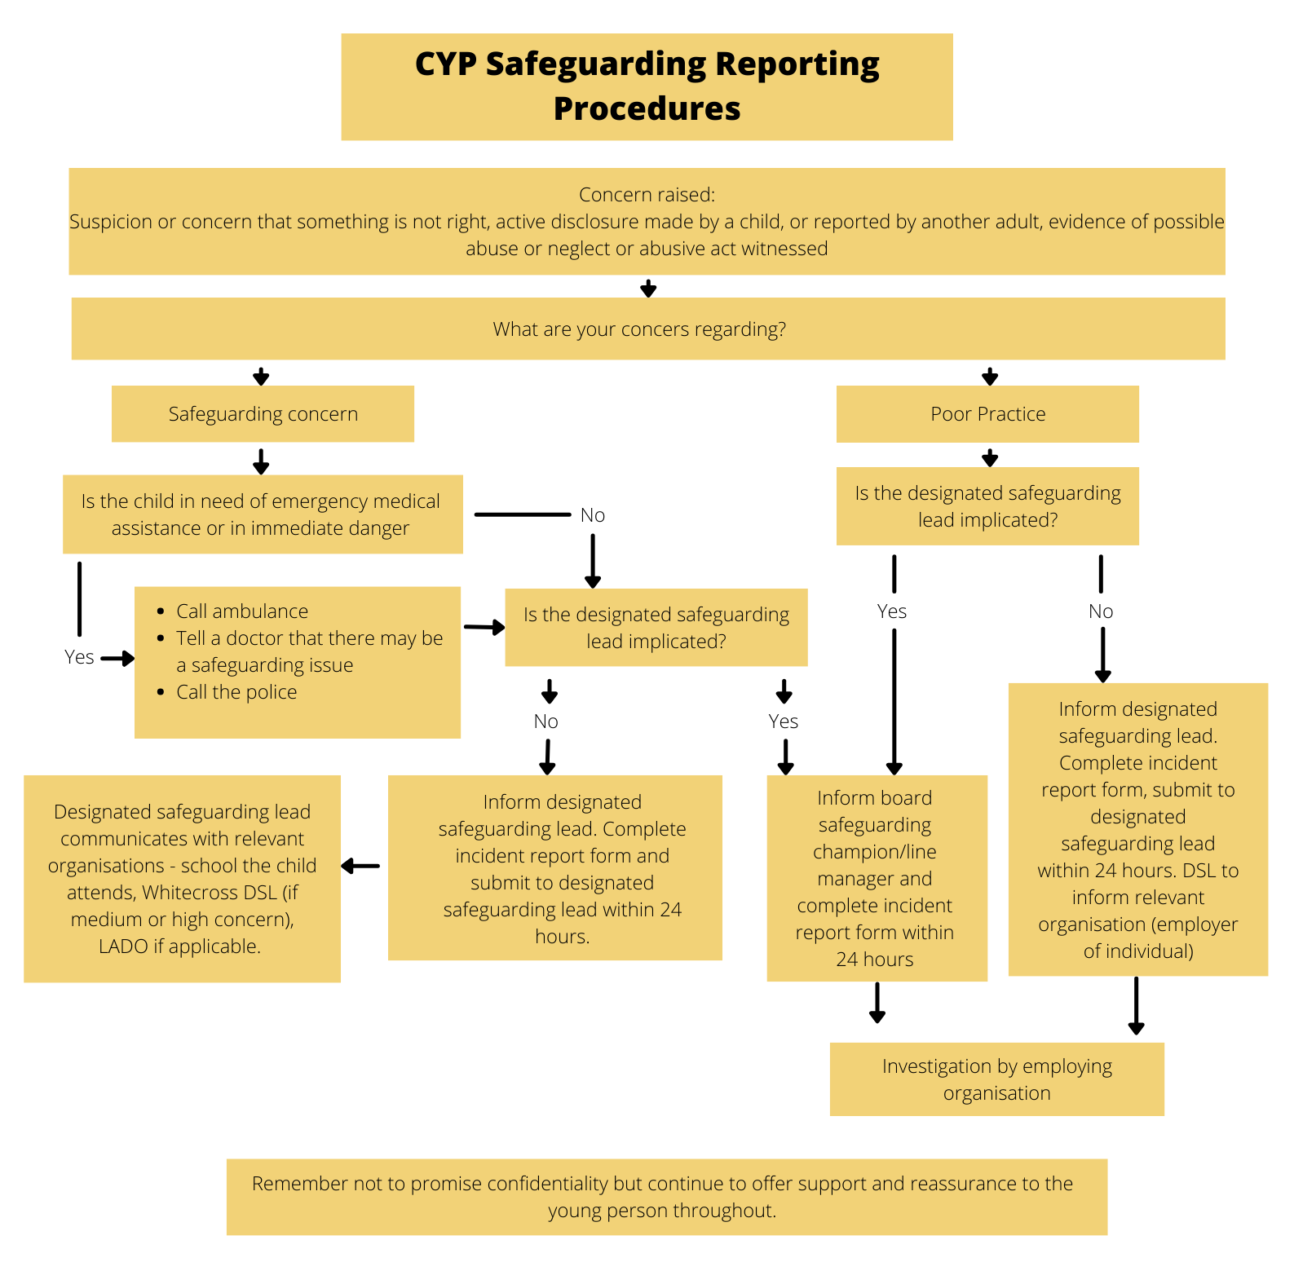

Incident to be recorded on an Incident Report Form: See Appendix 1

Appendix 3: Missing Young Person Procedure

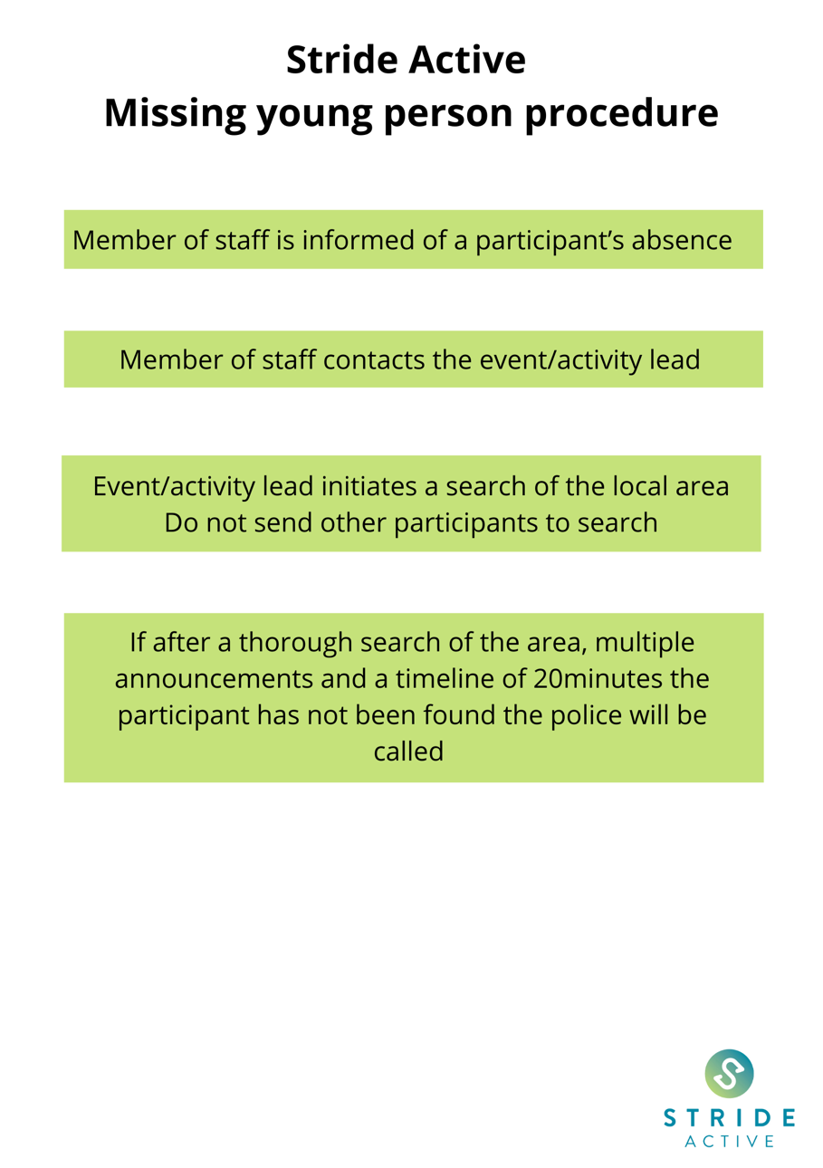

Appendix 4: HM Government Seven Golden Rules for Information Sharing

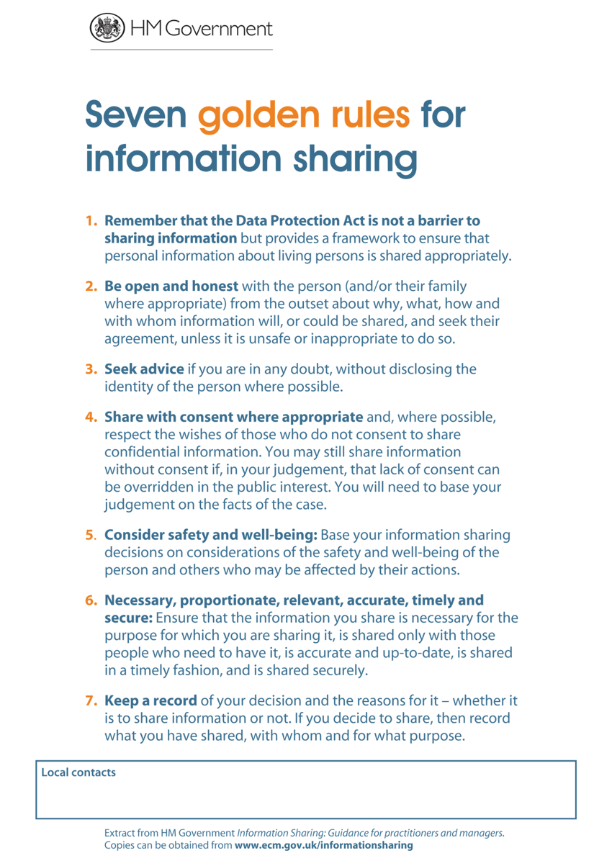

Appendix 5: Key Contacts

Name | Role
Emma Gardner | Designated Safeguarding Lead for Stride Active
Beky Williams | Deputy Designated Safeguarding Lead for Stride Active
Peter Knight | Stride Active Board Safeguarding Champion
Foster Erwin | Designated Safeguarding Lead for Whitecross High School
Alex Tootell  Michelle Giampalma  Marriann Wood | Deputy Designated Safeguarding Leads for Whitecross High School
Emma Bretherton | DSL Kington Primary School
Terry Pilliner | Designated Officer for Herefordshire
Herefordshire Safeguarding Children Partnership (HSCP)
MASH (Multi-Agency Safeguarding Hub)
Emergency Duty Team
NSPCC

Appendix 6: Level of Risk table

Low concern | Medium concern | High concern
- Minor injury, no professional treatment administered  - Low level breach of code of conduct by an adult  - Disclosure which could be considered a cause for concern | - Moderate injury – professional treatment administered  - Continual breach of code of conduct by an adult  - Disclosure made but no immediate danger | - Significant disclosure  - Evidence of abuse  - Significant injury

Appendix 7: Policy Amendments

Date | Section | Amendment | By
2/12/22 | Appendix 9 | Updated provider checklist inserted | Emma Gardner
2/12/22 | Appendix 5 | Key Contacts updated | Emma Gardner
2/12/22 | Appendix 2 | Reporting Flow Chart | Beky Williams
2/12/22 | Section 3 | Child-on-child abuse | Emma Gardner
4/10/23 | Appendix 5 | Key Contacts updated | Emma Gardner
8/11/2023 | Appendix 6 | Clarification in levels of risk table | Emma Gardner
22/11/2023 | Section 5.6 | Board Champion to be contacted if DSL and DDSL not available | Emma Gardner
22/11/2023 | Appendix 5 | Key Contacts updated | Emma Gardner
22/11/23 | Appendix 2 | Flowchart Updated | Emma Gardner

Appendix 8: Stride Active – Employee Code of Conduct

Where relevant, Stride Active employees must follow their host school code of conduct, in addition to the following:

Conduct
Employees should always:
- Provide an example for good conduct you wish others to follow.
- Respect the rights, dignity and worth of every individual and treat everyone equally.
- Act with dignity and display courtesy and good manners towards others
- Avoid swearing and abusive language and irresponsible behaviour including behaviour that is dangerous to yourself or others, acts of violence, bullying, harassment and physical and sexual abuse
- Challenge inappropriate behaviour and language by others
- Be aware that your attitude and behaviour directly affects the behaviour of others
- Never engage in any inappropriate or illegal behaviour
- Avoid destructive behaviour and leave athletics venues as you find them
- Not carry or consume alcohol to excess and/or illegal substances.
- Avoid critical language or actions, such as sarcasm which could undermine another’s self-esteem.

Appearance and Kit
All employees are required to be neat, clean, well-groomed and presentable whilst at work, whether working on the Company’s premises or elsewhere on Company business. Stride Active kit should be kept neat and clean and worn in a presentable fashion. Kit supplied must not be altered in any way without the Company’s prior permission.
Where kit is supplied by the Company, they remain the property of the Company. Employees must therefore take care of them and return them in good condition on the termination of employment.

Outside Commitments and Personal Interests:
All employees must make Stride Active aware of any potential conflicts of interest or secondary employment.

Appendix 9: Checklist for external providers

Checklist for external providers

Name of deliverer

Name of organisation (if applicable)

Qualifications | Name: | Date awarded:
Insurance | Policy number: | Date of coverage:
DBS | DBS number:  Please indicate the level of your DBS check:  Basic  Standard  Enhanced  Enhanced with Barred List | Date issued:
First Aid | Yes / No | Date awarded:

Name of person who completed the form

Date of form completion

